

**EMEU: Suggestions**

DM3-1

Authors: Karmele Elorza

Mark-up languages

Second Term

02 – 12 - 2021

**INDEX**

**TABLE OF ILLUSTRATIONS** 3

**1.** **INTRODUCTION** 4

**2.** **EMEU** 4

**2.1** Changes on **the main page** 4

**2.2** Changes on **the news page** 5

**2.3** Changes on **the modules page** 6

**2.4** Changes on **the Before mobility page** 6

**2.5** Changes on **the EMEU Network page** 7

**2.6** Changes on **the For teachers page** 7

# **TABLE OF ILLUSTRATIONS**

Img 1: willmeet 4

Img 2: Are You ready to go 4

Img 3 :Newsletter 4

Img 4: Getting Started icon 5

Img 5: News articles title length 5

Img 6: News title length 5

Img 7: Justify the information on News 5

Img 8: Misspelling and the information on the News 6

Img 9: WWW Module, dot instead of coma 6

Img 10: White space in Before mobility page 6

Img 11: Font family changes 7

Img 12: Change the dimensions of some images 7

Img 13: White space in For teachers page 7

# **INTRODUCTION**

On this document, will be explained the suggestions about the EMEU web page.

# **EMEU**

EMEU is a program to go abroad to study some modules that the school offers spending some days there.

On this document, will be talking about their web page and some suggestions to improve it.

## Changes on **the main page**

On the main page, there are some suggestions:

* Put another link on the **navigation bar** to go home instead of on the image.
* **CV and motivation letter**: the word “willmeet” needs a space between.

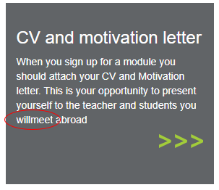

Img : willmeet

* **Are You ready to go**: it starts with “-” when others don’t and also it needs a capital letter. The “You” word doesn’t need the first capital letter but if it wants to be for attention, then put all the letters on upper case.

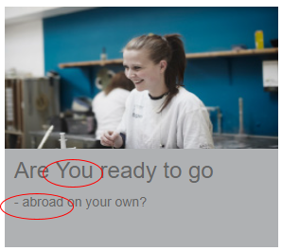

Img 2: Are You ready to go

* The margins of the footer. On the “sign up for Newsletter” part I would put more margin on top and on the bottom to a better visual image.

Img :Newsletter

* Put some hover effects when passing through the different articles to a better look of the page.
* When the images pass on the first part of this page, with some photos, the articles move.
* When resizing the window on the Getting started part, there is an icon that don’t resize well

Img : Getting Started icon

## Changes on **the news page**

On the news page, there are some suggestions:

* The news part articles title doesn’t show all if it is very long the title.

Img 5: News articles title length

* When clicking and article it goes to all the news instead of the article selected so put to go directly to the article chosen.
* On the news part, if the title is very long, it writes up the image.

Img : News title length

* On the news part, on read more, justify the information given.

Img 7: Justify the information on News

* On the news part, on the “EMEU. Minutes from the SG meting 4th of March 2021” article there are some information with “??”. Not put it until the information is known. There is a misspelling on participats”o”.

Img 8: Misspelling and the information on the News

## Changes on **the modules page**

On the modules page, there are some suggestions:

* WWW part on the details about the module: Responsible teacher(s). On the end there is a coma instead of a dot.

Img 9: WWW Module, dot instead of coma

* Justify all the paragraphs.

## Changes on **the Before mobility page**

On the Before mobility page, there are some suggestions:

* Centre the images or do not let that white space.

Img 10: White space in Before mobility page

* Font family change on the” Ready to sign up” part so put all the same font family.

Img : Font family changes

## Changes on **the EMEU Network page**

On the EMEU Network page, there are some suggestions:

* Newsletter archive: Quality Assurance is empty so erase it or put the information related.
* Quality Assurance is empty so erase it or put the information related.
* All the information of the blocks is given on the same page but the Newsletter archive block, displays it on another web page so change that to display on the same web page.

## Changes on **the For teachers page**

On the For teachers page, there are some suggestions:

* VET Teams is empty so erase it or put information related.
* It will be better if the images where centre and changing some dimensions because it seems like the people are very tall for example.

Img 12: Change the dimensions of some images

* Centre the images or do not let that white space.

Img 13: White space in For teachers page